**Changing your server.jar version!**

**Step 1 - Choosing Your Server Version**

Depending on what type of server you have. Or the type of .jar file that you want there will be different places to download the .jar file from! But all of the steps are still the same!

*(contact support on discord if you are having problems!)*

**For a Vanilla Minecraft .jar:**

For a vanilla minecraft server head over to [https://www.MCVersions.net](https://www.mcversions.net) and download your preferred version. We suggest only downloading and installing stable releases unless you know what you are doing, as the other ones may not be compatible. You can download your preferred version by clicking on “server jar” as seen in this gif…. If you have any issues be sure to contact support! <https://gyazo.com/ef25d5e60a5d1e4e298c8618aead0a82>

*(Step one done, now head to Step 2!)*

**For a Spigot / Bukkit .jar:**

For a Spigot/ Bukkit server head over to <https://getbukkit.org/download/spigot> and find your preferred version. You can download your prefered version by clicking download on the version you wish to download. As seen in this following gif… <https://gyazo.com/067bf21166e5650a2662ea8234aebe03>

*(Step one done, now head to Step 2!)*

**For a Forge .jar:**

For a Forge server head over to <https://files.minecraftforge.net/> and download your prefered version, you can find your version by clicking on the drop down menu on the left.We suggest downloading the Recommended version as it will be more compatible with your mods! To further install your forge server you will need to download it and export it onto your computer. These steps can be confusing, i would suggest asking support and we can help you out!

**Step 2 - Connecting To Your Server’s File Manager!**

When installing your .jar we would recommend deleting all of your server files and start from scratch, this way it saves all of the confusion when some of your plugins or mods do not support the new version. *(If you need any further help with this ask support!)*

To install your .jar file you will need to upload it to your syte space server, this can be done multiple ways, i would go back to Adam’s walk-through when he shows you how to connect with the FTP Client. *Once you are connected you can move onto Step 3!*

If you want to do it the other way, then all you need to do is head over to your SyteSpace server control panel… 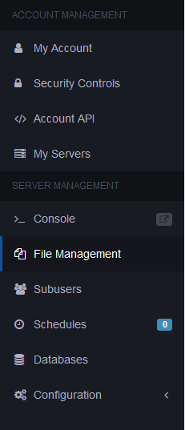

And navigate to your File Management section, once you are here you should see at the top right there is a blue upload button. If you click on this button it will open up your computer’s files, then you need to find your previously downloaded .jar file *(From Step 1)* and select it. https://lh4.googleusercontent.com/6r3hNjUqYkoZn0i5MqlxioREc5Wse99O4U3HxD-u1AyTntD3JSnsEWMj1i5_1Q9I-B5tCuMQmvgT_JdOQE_eI8Y6bk0IWMAmko0AH-1QQYAdUHTytQ-IFxSLrMF5leE-9cuY5Pok

Once you have it selected it should upload it onto your server! *(You can now move onto Step 3!)*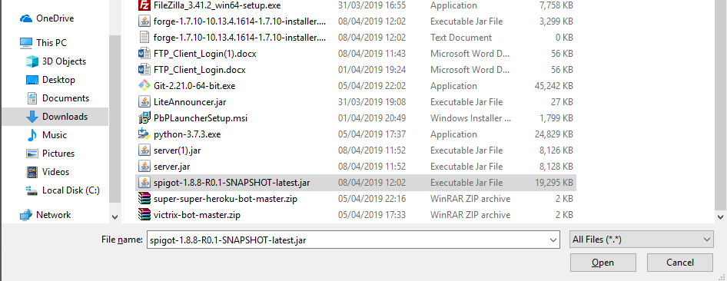

**Step 3 - Changing The Name Of Your .jar File!**

If you already know how to change the name of your file then you can skip this step, You will need to rename your .jar file to “server.jar”.

To rename your .jar file on SyteSpace all you need to do is head to your FIle Management section find your previously installed .jar file. https://lh6.googleusercontent.com/uI5vxQQcCXbXfUpAAKL83bRNPEkHmYhuiW0_7TMYYuEfXdcoIh0LSdrMRAbMpcHWi7p5A_vIPN41lT4Pdo89P6fgghmXhXxMUnWChAnSMAZGfCDzo-XsSjQ22csG2qwfuav0ocxN

Then you want to hit the small button on the far left of that .jar file. It should be 3 buttons inside a box .. Like shown here.https://lh5.googleusercontent.com/Kt1vR1qTAvpBRpkSFBGHE9lNhJnnPPxxN3fsXOJCr1dvIIw7XySymUGdfoPuqUwRWeujvwL3lHLHTBRTvqaDKByp98VcZdoym7DYtOcoNeFva5RtWHy6Wn70WAUc3CtkeIH0hZSd

Next you need to click that button and then click rename then you want to type in “server.jar” and click enter!

And that should be it! You should have your server all ready to start up, all you need to do now is navigate to your control panel and start your server!

**Having Further Issues/ Problems?**

No Problem! Tag me (@Callum#1273) or @Support in the #support channel in the SyteSpace discord server and we will be happy to assist you!

Syte Space Discord :   <https://discord.gg/Qu2BXPV>